INTRODUCTION

AWS offers a massive range of services for every business, starting with basic elements, like compute, storage, and network security tools, through complex solutions like blockchain, machine learning, or artificial intelligence, and robot development platforms, all the way through very specialized tool sets, like video production management systems, and orbital satellites you can rent by the minute.

Almost all modern computing centres around a basic client-server model.

Server called Amazon Elastic Compute Cloud or EC2 (AWS Language) virtual server

Key Concept

Pay only for what you use

Key Value

Pay for what you need

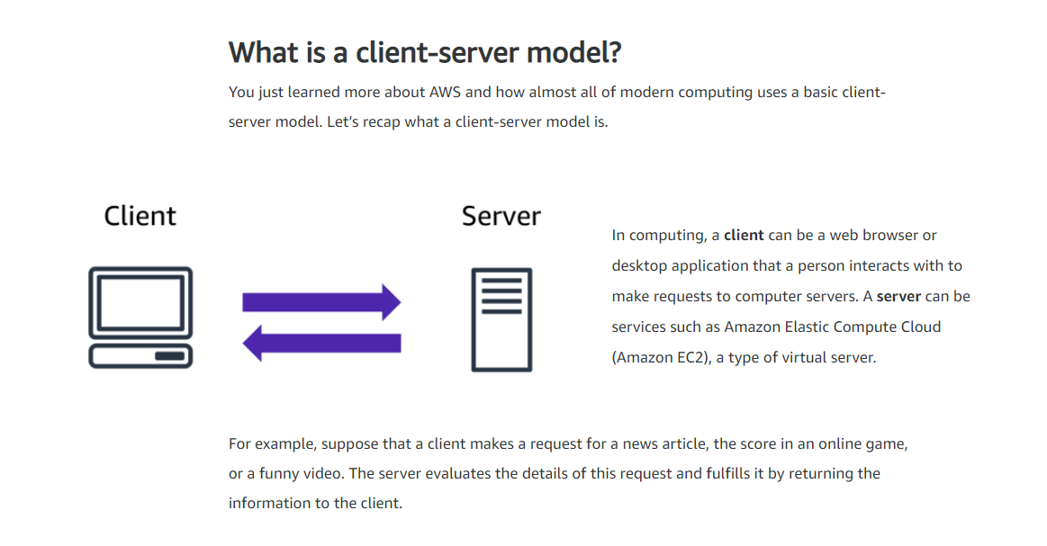

CLOUD COMPUTING

The three cloud computing deployment models are cloud-based, on-premises, and hybrid.

